#### Barclay Bicksler

#### 11/24/2020

#### IT FDN 110 A Au 20: Foundations Of Programming: Python

#### Assignment 06

Menus and functions oh my

In last week's assignment it teased the fact that this week we would take the same menu and use functions to run through them. I was excited to see this because I tried something like this a few weeks back. I was somewhat able to put functions in my code that week, but there were several things I wasn’t able to do. Mostly around variables. But this week certainly covered that.

I realized quickly that each menu option would need to be a function, but one of the things that I struggled with last time was how to pass the variables to the function, or maybe better put how to capture the variables to pass to the function. We learned this week that you can create a function to look for passed variables, which solved one issue. We also learned you should separate the input from the processing functions, which solved my second issue. Figures one and two below show parts of the Processing and IO function sections.

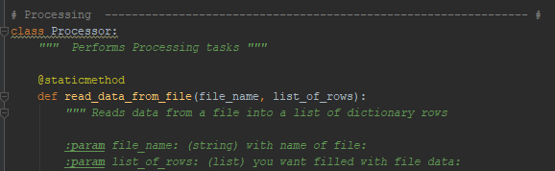

Figure 1 - The start of the processing functions

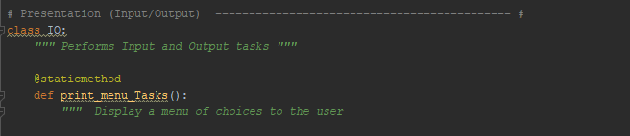

Figure 2 - The start of the IO functions

Seeing how the IO and processing functions work together was an eye opener. I has to wrap my head around the proper order of events and also how and when to set different variables. I was pretty lost and having issues getting my functions to work properly until I reviewed the help video and document. I felt by that point that I had a good grasp of what functions needed to be called, but really didn’t get the variables. This document got me started, one I went through menu item 1 it made much more sense. I actually kept getting an error because in my processing function I was returning too many variables, (task, priority and list_of_lines), which created an error. The help doc allowed me to find that.

I was able to do menu item 2 on my own. I struggled with 3 and it turned out I was declaring the wrong variables in my processing function, once I fixed that it was all good. I was then able to do menu 4 based on what I learned from menu 3.

This was a challenging assignment and I learned a lot, I appreciate the help doc that was posted as I don’t think I would have been able to complete this assignment without it. At the same time I was able to learn my mistakes and had a chance to apply my learning right away so it was a good exercise. I am both excited and afraid to see what is in store next week.